Unitarian Universalist Community Church
Worship Service - Sunday, December 17, 2017

Today at UUCC

Services at 9:15 & 11:00 a.m. “What’s in a Name”*
Rev. Carie Johnsen
UUCC Common Read – Option 2 (Waking up White),
12:30-2:00 p.m., C-FH
Faith Café: Caroling, 2:30-5:30 p.m., C-FH
Private Rental, 6:30-9:30 p.m., C-Sanct

* Let’s explore the Unitarian Universalist Sources together. What name do you give to that which cannot be fully known? To what source(s) do you turn to guide, restore, and sustain your living? This interactive service will make room for the sciences and poetry, the mystics and the seekers, the cynics and the faithful.

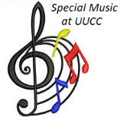
**TODAY in our services**Alex Mathieu will be sharing more music with us, as he prepares for his college auditions. He will play Frederic Chopin's monumental solo piano piece, "Ballade in G minor, Op. 23" which was completed in 1835. Chopin was 25 years old when he composed this piece, the first of four Ballades.

TODAY-JOIN US for our Caroling FAITH CAFE
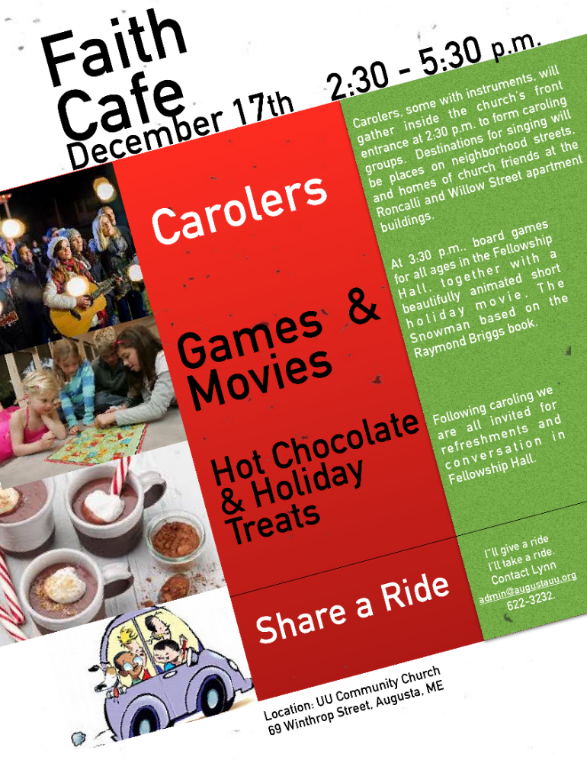
ALL ARE INVITED:
Join us as we spread out into local neighborhoods to sing carols and spread cheer. Among our destinations are the homes of Nancee Campbell and Maggie Ricker. After caroling, everyone returns to the church for hot chocolate, refreshments, a short holiday movie and games. Questions, contact Hannah at 293-9377 or hannahuu3@fairpoint.net.

Notices
Gifts for the Giving tree are DUE TODAY.
Thank you to all of you that have contributed!

This Week at UUCC …

Monday, December 18, 2017
Newsletter articles DUE to newsletter@augustauu.org
Private Piano Lessons, 2:30-6:00 p.m., C-Sanct
Small Group Ministry, 5:00-7:00 p.m., C-Comm
Peaceful Heart Sangha, 6:30 p.m., C-Sanct
Join this mindfulness meditation group that meets every Monday from 6:30 – 8:00 pm for sitting and walking meditation, readings and sharing in the sanctuary. Introduction to meditation is available by request.

Tuesday, December 19, 2017
Christine Letcher, 9:00-11:30 a.m., C-Sanct
Al-ANON, Noon, C-Rbsn
Book Group: Christ for Unitarian Universalists
Group 1 meets 2:00-4:00 p.m. – (C-FH)
Group 2 meets 6:00 – 8:00 p.m. – (C-FH)
Pastoral Ministry Team Mtg, 4-6:00 pm, D-Prl

Wednesday, December 20, 2017
Communications Work Group,
11 a.m. – 12:30 p.m., C-Comm
Gentle Yoga, 5:00 p.m., C-FH
Everyone is welcome to Wednesday Yoga at the UUCC. No experience needed; just curiosity. People are welcome to drop in, come every once and a while, or become regular attenders. Classes are FREE.
Rental: Just Guys, 6:30 – 8:00 p.m., C-FH
Small Group Ministry, 6:30-8:30 p.m., C-Rbsn

Thursday, December 21, 2017
Small Group Ministry, 10:00 a.m. - Noon, C-Rbsn
Board of Trustees Meeting, 6:00 p.m., C-FH

UUCC Board Meeting Agenda
December 21, 2017
6:00-8:00 PM Fellowship Hall

-Gathering and lighting the chalice
-Checking in with each other
-Clerk’s reports: November.-Karen Foust
-Treasurer’s Report—Nancy Fritz
-Minister’s Report- Rev. Carie Johnsen
• Rental agreement for UUCC Campus Buildings
• Institute in Florida-January
-Old Business
-New Business
Personnel: Insurance for Lynn Smith; PT employee policy
Hiring RE Coordinator: Job description, Job posting
Finance Committee report-Diane Smith Howard
-Other business
Anniversary final celebration: June 10? (flower communion Sunday)
Faith Café-Decide March date

**Board meetings are open to ALL. If you have an item you would like the Board to consider, please contact Martha Naber, Board President at naber@gwi.net or call 872-0913.*

Friday, December 22, 2017
Drum Circle, 6:00 – 8:00 p.m., C-Sanct

Saturday, December 23, 2017
CANMP Women’s Talk and Tea, 10 a.m. – Noon, C-FH
Private Piano Lessons, 1:45-6:30 p.m., C-Sanct

Sunday, December 24, 2017 <Christmas EVE>
Services at 9:15 & 11:00 a.m. “Winter Solstice: Return of the Light”** Goddess/Earth Circles
Rev. Carie Johnsen

**This ancient celebration of Light and Dark sets the stage for other celebrations of the season. Explore together the richness of the longest night and the expectation of rebirth of the sun. Take the essence of this celebration with you as you experience the many variations in the Season of Light.

A Christmas Eve Tradition:
Carols, Light, and Readings

December 24, 2017 - 5:00 p.m.

Our annual Christmas Eve Service offers people of all ages the opportunity to center their spirit around the many gifts of the holiday season: peace and joy, light and love.

Upcoming Events

Wed., Dec. 27th, Craft Circle, 2-4 p.m., C-FH
We welcome all crafters in yarn, paint, sewing, cardmaking, “anything” to join us as we gather to “do our own thing” and to chat as we create. It is a great opportunity to get to know each other and share our talents, too. If you have questions, speak to Martha Naber or Jean Sizelove. Hope to see you there!

Thurs. Jan. 4th, Books for Serious Readers
Join us from 12:30 – 2:30 p.m. in Fellowship Hall as we meet to discuss The Underground Railroad by Colson Whitehead. According to the New York Times Review, “He has told a story essential to our understanding of the American past and the American present.” Join us as we explore this powerful and revealing book. FMI contact Kathy Kellison 445-4415 or kell6787@gmail.com or June Zellers at 582-5862 or jzellers@roadrunner.com.

Sunday, January 7th, Adult R.E. Sacred Sexuality Series BEGINS, 12:30 p.m., C-FH
Sacred Sexuality: A Journey of a Lifetime!
The Spirituality of Human Sexuality.

Brown bag lunch encouraged.
We will provide desserts, tea, and coffee.
Adults of all ages welcome.
Attend one or more sessions.
The series is free and open to the public.

Sundays from 12:30 – 2:30 p.m.
Sessions include:
Jan. 7th That's the Story of Love?
Feb 4th Dialogues with a New generation
Mar 4th Body as Temple
Mar 18th SEXcessful Aging

Please see the November newsletter AND
the bulletin board for all the details.

Sponsored by the Pastoral Ministry Team at Unitarian Universalist Community Church.
Please register for this event at ADMIN@AUGUSTAUU.ORG

UUCC Office Hours

UUCC Office Hours <hours for next week>
Monday ----------------------------------<No office hours>
Tues. Wed. AND Thurs. ---------9:00 am to 4:00 pm
Friday -------------------------------------< No office hours >

Rev. Carie’s Office Hours:
Monday No office Hours
Tuesday 1:00 pm – 6:00 pm
Wednesday 2:00 pm – 6:00 pm
Thursday No office Hours (Writing Day)
<other hours available by appointment>

Rev. Johnsen: 623-3663 or (508) 221-5295 or revcariejohnsen@gmail.com

Caring Cooperative support, contact Rev. Carie Johnsen.

Sunday Services / Staff Contact information:

Office Administrator, Lynn M. Smith, admin@augustauu.org, Phone 622-3232

Youth Advisor, Monique McAuliffe youthadvisor@augustauu.org

Sunday Morning Religious Exploration Coordinator, Brigid Chapin, SundayREcoordinator@augustauu.org

Music Director, Bridget Convey, musicdirector@augustauu.org

