WITCHCRAFT: TWO SESSIONS
GODDESS/EARTH CIRCLES, January 25, 2015, 12:15-2:00pm
Witchcraft: Reclaiming Our Identity

“The witches, the wise women and the healers were also the counselors. It’s a whole other tradition of learning that has been suppressed because it has political implications.” Starhawk

THE NEW FOREGROUND If possible, please read this section prior to the session.

Violence against women is a major problem both historically and in contemporary cultures around the globe. In her book Gyn/Ecology Mary Daly has documented the world-wide brutalization of women that occurred as patriarchal religions came to rule the social order in many cultures. In India “The Hindu rite of suttee spared widows from the temptations of impurity by forcing them to ‘immolate themselves,’ that is, to be burned alive, on the funeral pyres of their husbands ... Since their religion forbade remarriage and at the same time taught that the husband’s death was the fault of the widow ... everyone was free to despise and mistreat her for the rest of her life.” In China “the ... ritual of footbinding was a thousand-year-long horror show in which women were grotesquely crippled from very early childhood.” Daly quotes Andrea Dworkin: “the hideous three-inch-long ‘lotus hooks’ -which in reality were odiferous, useless stumps— were the means by which the Chinese patriarchs saw to it that their girls and women would never ‘run around. “
Daly points out that some atrocities “are unspeakable—incapable of being expressed in words because inexpressibly horrible. Such are the ritual mutilations—excision and infibulation—still inflicted upon women throughout Africa today, and practiced in many parts of the world in the past.” She quotes the definitions offered by Fran P. Hosken:
“1. Sunna Circumcision: removal of the prepuce and/or tip of the clitoris.
- Excision or Clitoridectomy: excision of the entire clitoris with the labia minora and some or most of the external genitalia.
- Excision and Infibulation (Pharaonic Circumcision): This means excision of the entire clitoris, labia minora and parts of the labia majora. The two sides of the vulva are then fastened together in some way either by thorns ... or sewing with catgut.”³⁷
Daly continues, “It should not be imagined that the horror of the life of an infibulated child/woman ends with this operation. Her legs are tied together, immobilizing her for weeks, during which time excrement remains within the bandage ... she can look forward to a life of repeated encounters with ‘the little knife’—the instrument of her perpetual torture. For women who are infibulated have to be cut open—either by the husband or by another woman—to permit intercourse. They have to be cut open further for delivery of a child. Often they are sewn up again after delivery, depending upon the decision of the husband.”
Because of the overlay nature of patriarchal attitudes, these brutal treatments of women are frequently in opposition to older aspects of the religious traditions and historical circumstances of these cultures. Even the political and secular histories of these areas of the globe often reveal underlying woman-honoring attitudes and practices.
Many non-governmental organizations worldwide, most made up of women from the cultures where some of these practices still exist, have made violence against women, in its many forms, a priority. The United Nations promotes the equality of women, having held four international conferences from 1975 through 1995 where the international agenda for obtaining equal rights for women free from violence were set. Numerous member countries of the United Nations have programs in place to combat these attitudes and practices. The United States is no exception when it comes to violence perpetuated against women. Historically women in the United States have suffered many physical and mental brutalities which sadly are still in evidence.

Historically, the Western Christian form of brutality against women was witch-burning. What happened to the Old Religions of Europe when the patriarchal deities came into power? Many women have come to believe that the Old Religions survived in secret as witchcraft. At first, Christianity brought little change because simple people saw it as a new version of the Mother Goddess and her Divine Child who dies and is reborn. Persecution began slowly, but witchcraft was eventually declared heretical and in 1324 an entire Irish coven was burned. As the stability of the medieval church was shaken and the feudal system crumbled, the church could not tolerate rivals.
In 1484 the Papal Bull of Innocent VII turned the Inquisition against the Old Religion. The Malleus Malleficarum, or Hammer of the Witches, was published in i486, and a reign of terror began which lasted into the eighteenth century in Europe. “All witchcraft stems from carnal lust which in women is insatiable,” stated the Malleus Malleficarum. Every imaginable torture was used in an attempt to obtain confessions. The Old Religion became secret, passed down only in families. By the time the persecutions ended only hideous stereotypes remained—witches as evil, ugly hags, laughable to modern people. The story of the religion of Wicca and the witch craze of the fourteenth to sixteenth centuries is told in this session.
Modern women, dissatisfied with the image of Mary and the absence of female imagery in contemporary Judaism and Protestantism, are searching intellectually and emotionally for symbols that can express female religious experience. The recent discoveries of archaeological artifacts and writings about the ancient Goddess religion have caught the imagination of women involved in the search for religious symbols. As women seek new ways to express their religious feelings the Goddess symbol has re-emerged and has inspired us “to see ourselves as divine, our bodies as sacred, the changing phases of our lives as holy, our aggression as healthy, our anger as purifying, and our power to nurture and create, but also to limit and destroy as necessary, as the very force that sustains all life.” Experience the new Goddess religion that is taking shape today.

JANUARY 25, 2015, 12:15-2:00PM
Fellowship Hall
You are invited to bring light snack to share, or your own lunch, or just come and enjoy!
We look forward to being together to explore this critical topic which has historic and personal impact.

The session is open to all genders and multiple ages/
OPENING RITUAL
Three Breaths. Let us be conscious of three breaths.
As you inhale the first breath, be aware of what you are leaving behind. As you exhale, let go of that which would keep you from being here completely.
As you inhale the second breath, feel the presence of being here. As you exhale, notice those who are here with you.
As you inhale the third breath, step over the threshold into the space where spirits meet. As you exhale, let your spirit join with other spirits present.

Honoring the Directions [SLT #446, Goodwin, ad.]
Sacred space is formed by calling upon all the directions and inviting the elements of the natural world to be present

Spirit of the East, spirit of air,
Of morning and springtime:
Be with us as the sun rises,
In times of beginning,
Times of planting.
Inspire us with the fresh breath of courage As we go forth into new adventures.

Spirit of the South, spirit of fire,
Of noontime and summer:
Be with us through the heat of the day
And help us to be ever growing.
Warm us with strength
And energy for the work that awaits us.

Spirit of the West, spirit of water,
Of evening and autumn:
Be with us as the sun sets
And help us to enjoy a rich harvest.
Flow through us with a cooling
Healing quietness and bring us peace.

Spirit of the North, spirit of earth,
Of nighttime and winter:
Be with us in the darkness,
In the time of gestation.
Ground us in the wisdom of the changing seasons
As we celebrate the spiraling journey of our lives.

UNISON:
In the name of Isis of the thousand breasts,
May my purpose be blessed;
In the name of Diana, may my spell be strong;
In the name of Hecate, queen of heaven, queen of hell
May my purpose be accomplished.
Activity. Paper and crayons are available to express your feelings in pictures or in words as the following narrative is read:

Some say that when the last Goddess temples were closed the old Goddess religions went underground and survived in secret as witchcraft. At first Christianity brought little change because most people saw it as a new version of the Mother Goddess and Her Divine Child who dies and is reborn. Persecution began slowly, but witchcraft was eventually declared heretical, and the full power of Christendom, Church and State, was used to stamp it out. A holocaust of terrifying proportion spread across Europe.
When we speak of witchcraft, we are speaking of Goddess religion. When we speak of witchburning we are speaking of the burning of an estimated one to nine million people, 80 percent of them women. We are speaking of an unspeakable era in women’s religious history
Initially the witch craze focused on unmarried women, spinsters and widows, and served to rid society of these “unacceptable” groups. Eventually the craze got out of hand, and even the most docile married women were accused. Some villages were left with only one living woman.
Every imaginable torture was used in attempts to obtain confessions and the names of other witches. One reads of limbs forced asunder, eyes driven out of the head, sinews twisted from the joints, and shoulder blades wrung from their place. The executioner was said to flog with the scourge, crush with screws, load down with weights, stick with needles, burn with brimstone, and singe with torches.
Even more unspeakable was the use and abuse of children. Not only did they watch their mothers being burned alive, but they were often used as legal witnesses against their mothers. Little girls as young as seven were forced to give testimony, which was used to condemn their mothers to death. The burden of self-hatred carried by these daughters has been handed down through the generations to our own time. In Mary Daly’s words, “Without knowledge and consent, women are trained to continue the ritual murder of female divinity, burning the witch within themselves and each other.”⁴²
You are a witch. Think about that! You are a witch by being female, untamed, angry, joyous, and immortal.
Take a few minutes to reflect and to complete your drawings or word pictures. You are invited to describe briefly the feelings you experienced as the narration was read. The global nature of the atrocities committed against women—widow burning in India, Chinese footbinding, African genital mutilations—are mentioned in The New Foreground.

Discussion
As women seek new ways to express religious feelings, the Goddess has become a symbol of inspiration. Starhawk says in her book, The Spiral Dance: A Rebirth of the Ancient Religion of the Great Goddess, the Goddess “allows us to see ourselves as divine, our bodies as sacred, the changing phases of our lives as holy, our aggression as healthy, our anger as purifying, and our power to nurture and create, but also to limit and destroy as necessary, as the very force that sustains all life.”
Starhawk points out that the symbolism of the Goddess is not parallel to the symbolism of God the Father. “The Goddess does not rule the world; she is the world.”⁴ She is manifest in each of us and can be known by every person. In witchcraft each person must reveal her or his own truth. Sexuality is sacred. Religion is a matter of relinking with the divine within, and with the divine in all the human and natural world.
The patriarchal image of God as outside nature has allowed us to exploit and destroy nature. Pollution and ecological destruction have resulted. Witchcraft is a religion of ecology that recognizes the interdependence of all living things.
The symbol of the Goddess appeals to men too. It allows them to experience and to integrate in themselves qualities usually called feminine.
The Goddess symbol does not exclude the male; it contains him.
The ethics of witchcraft are based on the concept of the Goddess as immanent in all forms of life, including human beings. Love for life is the basic ethic, and witches are bound to honor and respect all living things. Justice is seen as an inner sense that each act brings about consequences that must be faced responsibly. What is cultivated is an inner sense of pride and self-respect. No one has the right to coerce another.
Witchcraft today is a new religion and it has some important attitudes for us to consider. (Groups)
Small Groups: 20 minutes total
Attitudes: The divine is internalized as the Goddess or God within each of us, and so each person is responsible for her or his own beliefs and behavior;
- Today’s witches believe in a democratic process of shared leadership;
- The divine is imagined as immanent in all of life, so witchcraft is vitally concerned about the well-being of the earth.
Reflect on the impact of the three attitudes on your spirituality. (10 minutes)

Affirmations:
“Mother Goddess is reawakening, and we can begin to recover our primal birthright, the sheer, intoxicating joy of being alive. We can open new eyes and see that there is nothing to be saved from, no struggle of life against the universe, no God outside the world to be feared and obeyed; only the Goddess, the Mother, the turning spiral that whirls us in and out of existence, whose winking eye is the pulse of being—birth, death, rebirth—whose laughter bubbles and courses through all things and who is found only through love: love of trees, of stones, of sky and clouds, of scented blossoms and thundering waves; of all that runs and flies and swims and crawls on her face; through love of ourselves; life-dissolving world-creating orgasmic love of each other; each of us unique and natural as a snowflake, each of us our own star, her Child, her lover, her beloved, her Self.” Starhawk

Create a group affirmation regarding witchcraft. These will be read as part of the closing. (10 minutes)

CLOSING

Sharing the affirmations from the groups.

A witch lives and laughs in every woman. She is the free part of each of us. There is no joining WITCH. If you are a women and dare to look within yourself, you are a witch. You are a witch by being female, untamed, angry, joyous and immortal. You are a witch by saying aloud ‘I am a witch,’ and thinking about that.
From “The Witch Manifesto,” Women’s International Terrorist Conspiracy from Hell, NY, 1968

Charge of the Goddess Traditional by Doreen Valiente, as adapted by Starhawk:
Listen to the words of the Great Mother, Who of old was called Artemis, Astarte, Dione, Melusine, Aphrodite, Cerridwen, Diana, Arionrhod, Brigid, and by many other names:
Whenever you have need of anything, once a month, and better it be when the moon is full, you shall assemble in some secret place and adore the spirit of Me Who is Queen of all the Wise.
You shall be free from slavery, and as a sign that you be free you shall be naked in your rites.
Sing, feast, dance, make music and love, all in My Presence, for Mine is the ecstasy of the spirit and Mine also is joy on earth.
For My law is love is unto all beings. Mine is the secret that opens the door of youth, and Mine is the cup of wine of life that is the cauldron of Cerridwen, that is the holy grail of immortality.
I give the knowledge of the spirit eternal, and beyond death I give peace and freedom and reunion with those that have gone before.
Nor do I demand aught of sacrifice, for behold, I am the Mother of all things and My love is poured out upon the earth.
Hear the words of the Star Goddess, the dust of Whose feet are the hosts of Heaven, whose body encircles the universe:
I who am the beauty of the green earth and the white moon among the stars and the mysteries of the waters,
I call upon your soul to arise and come unto me.
For I am the soul of nature that gives life to the universe.
From Me all things proceed and unto Me they must return.
Let My worship be in the heart that rejoices, for behold, all acts of love and pleasure are My rituals.
Let there be beauty and strength, power and compassion, honor and humility, mirth and reverence within you.
And you who seek to know Me, know that the seeking and yearning will avail you not, unless you know the Mystery: for if that which you seek, you find not within yourself, you will never find it without.
For behold, I have been with you from the beginning, and I am That which is attained at the end of desire.

Pentacle | GODDESS/EARTH CIRCLES, February 22, 2015, 12:15-2:00pm  Witchcraft: A Healing Practice  Herbs and Magick, Ritual and Symbolism  What part do we have in healing ourselves and being present in the healing of others?

GATHERING FORMAT
*Gather the food for sustenance. You are invited to bring finger foods to share.
*Invoking the Goddess (Human Body Pentacle) and *Honoring the Elements (Pentacle)
*Healing Practices – From the reading below
*Small Groups for meditation using pentacles
*Reflections and Closing

The pentagram and pentacle are sometimes used interchangeably. More precise meanings are:
The word pentagram comes from the Greek: "pente means 5 (as in Pentagon). "Gram" comes from the Greek verb graphein, "to write. Pentagram refers to a five pointed star, or "any figure of five lines, often used for a symmetrical, five pointed star drawn with a single line.
An upright pentacle is generally defined as an upright pentagram surrounded by a circle.

The Inverted Pentagram: The upright or witch’s pentagram (single point on top) represents Spirit. The inverted pentagram (single point down) is said to represent Satan and Chaos.

“The traditional tool of earth is the pentacle, a five-pointed star in a circle…It’s five points stand for the four elements, plus the fifth, spirit. They also stand for the five senses, for our five fingers and toes, and for the human body with legs apart and arms uplifted to invoke the Goddess. The circle around it stands for the wheel of life. For us the pentacle is a symbol of wholeness and balance, and of the ancient mysteries of our tradition.” Starhawk, Circle Round (p. 378)

Symbolism and ritual are tools for engaging spiritual practice. When they become ‘the way to do things’, they lose the power to engage and may begin to restrict the dynamic flow of energy.

Human Body, Invoking the Goddess
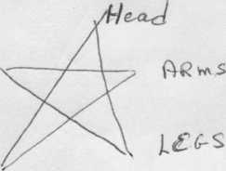 | Human Body, Invoking the Goddess

Stand with your feet apart, giving firm connection with the earth.

Legs: Breathe deeply, and feel the power of the earth, of your body.

Arms: Breathe deeply, stretch your arms and feel your power in the connections within and beyond our selves.
Head: Breathe deeply, hold your head high and feel the awakening of our conscious mind to the beginnings of our own human psyche, and then moving beyond our limited five senses, to explore the infinite possibilities that exist within the Universe.

Circle: Envision the circle surrounding the five points of your legs, arms, and head, holding all that you are. Bring your presence into this space, where we may be with each other.
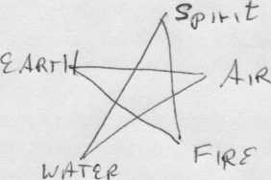 | Honoring the Elements

Traditionally four of the five points of the pentagram has been attributed to the four sacred elements, which are also attributed to the directions, with the fifth point (uppermost) representing Spirit. The Circle around the star represents sacred space.
Spirit: topmost point of the star, symbolic of the Divine, and the All that Is.
Air: right hand, symbolic of Intelligence and the Arts.
Fire: right leg, symbolic of Courage and Daring.
Water: left leg, symbolic of Emotions and Intuition.
Earth: left hand, symbolic of Stability and Physical Endurance.
Circle: May the circle that surrounds the points hold the universe, of which we are a part.

Healing Practice: Ritual, Herbs and Magick by Mary Shifman, UUCC
In his book, The Solatairy Practitioner, Scott Cunningham, explained his view of the divine, and his explanation is one that resonates for me. He said that there is a supreme force that governs the world and the gods and goddesses of every religion represent aspects of the Divine. Since the Source is too infinite for us to even conceive, it is easier for us as humans to connect with it in small increments. Ritual is one of the ways in which we do this.

Ritual isn’t just a formal, intellectual or religious rite. We each have our own personal rituals. Some people start their mornings by meditating, or reading inspirational writings or running, etc. Every day I play 3 games on my Kindle. These personal rituals serve to center us, clear our minds, and focus us so that we face the day recharged.

Ritual, in the religious sense, does much the same thing, but it is also a component of worship. We cast a circle and invite Divinity into it. The circle keeps out all unwanted forces and serves to give Divinity a sacred place in which to meet with us.

Others view ritual as a means, and the circle as a workplace for magickal work. Interaction with Divinity always comes with high levels of energy and the circle serves to keep that energy in place. When it comes time to actually cast the spell, the practitioner pulls that energy into him/herself, focuses it, and uses it to fire their spell.

I don’t mean to imply that it’s an either or situation, nor do I make a judgment. Many who use religious ritual and the sacred circle as a place of worship, also use it for magick. Regardless of the reason you work magick, remember ethical use is imperative. Magick should never be used to coerce or harm others in anyway, hence the rule of three: any harm you do to another through magick will return to you three times over. It’s my understanding that the only exception to this rule is for defense.

Herbs and other plants have long been used by old-world pagans, Native Americans and indigenous peoples on all continents. For centuries common plants that were used for seasoning or raised in gardens for enjoyment, were used for medicinal purposes. Pagan herbalists were labeled as witches due to their ability to create cures using these so-called ordinary plants. As witches, these healers were both feared and revered. Until a few years ago, these herbs could be only be purchased in health food stores. Scientist and medical experts ridiculed those who held any belief in their beneficial qualities and tried to curtail the marketing of them. Today herbs and other plants are recognized for their medicinal qualities. They can be found in many forms: capsules, tinctures, oils, and aroma therapy. We can purchase many of them in pharmacies, department stores and grocery stores. Even doctors recognize the beneficial nature of some herbs and encourage patients to use them.

Herbs and plants are also used in non-medicinal ways in both religious ritual and magickal work. Different herbs are associated with specific deities, holy days, stages of the moon and magickal work. Twenty odd years ago, it was hard to find sources of information on Wicca and related topics. Happily, times have changed and now days books can be found in local bookstores as well as on the Internet. I’ve only given a brief overview here, and I encourage you to check them out if you have any desire to learn more.

Practitioners differentiate the “slight of hand” form of magic that magicians used from the type what the practice of magic by spelling it with a “k”, hence I used this spelling magick as I refer to the magick that is used in rituals and/or for the purpose of creating spells. One form deals with the creation of illusions while the other results in an actual change of some kind.

Many practitioners believe that there is no such thing as white or black magick, and I tend to agree. Magic is like electricity. In of itself, electricity has no good or bad nature. It simply is. Electricity can be used to cook meals, light houses or save lives—or it can be used in prisons to execute people. Is one type of electricity different than the other? Of course not. It’s only the way that it is used that differs.

Magick is similar to prayer and it does have the potential to manifest change. It should be used only to benefit others, that’s one of the reasons why the Wiccan code of ethics is so strict. We are free to perform magick as long as we use it according to the rules of morality, and if we don’t we must pay the consequences.
You’ve heard the saying, what goes around comes around — well it does — and in this case, it comes around 3 times!

SMALL GROUP MEDITATIONS/REFLECTIONS

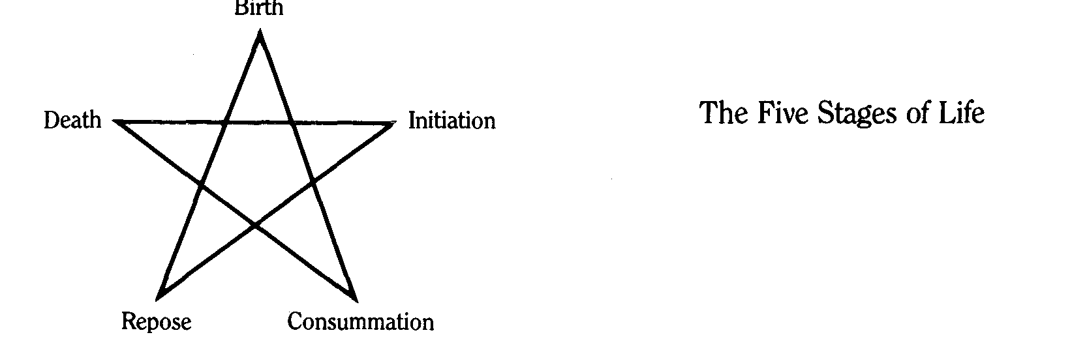
Hold the Pentacle of the Stages of Life, and reflect on the meaning of each stage as it occurs in a lifespan and within the span of each new activity or relationship. Trace the interlocking lines and reflect on their meanings. Love is linked to Birth and Death. Death is linked to Love and Initiation.
Birth: the beginning, the time of coming into being;
Initiation: adolescence, the time of individuation;
Love (Conummation): the time of full adulthood, sexuality, responsibility;
Repose: the time of advancing age, of reflection, integration, wisdom;
Death: the time of ending, of letting go, of moving toward rebirth.
Circle: the holder of lifetime, our own and as we are with others throughout their lifetimes.
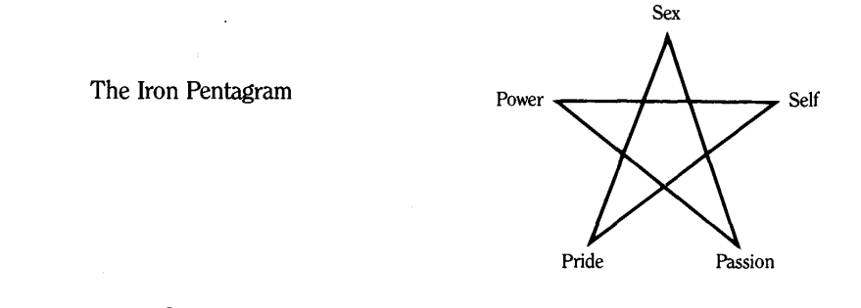
Hold the Iron Pentagram, in both hands. Breathe deeply. Reflect on each part and interrelatedness of the parts.
a. Sex is the manifestation of the driving life force energy of the universe. It is polarity, the attraction of Goddess and God, the on/off pulse that sustains the universe, the orgasmic, ecstatic harmony that sings within each being.
b. Self is identity, individuality. Each of us is a unique manifestation of the Goddess, and that individuality is highly valued in the craft. Self-love is the foundation of all love. ‘Celebrate yourself, and you will see that Self is everywhere.’
c. Passion is the force of emotion that gives color and depth and vitality to life. Joy, sorrow, ecstasy, anger, fear, pain, love—the Goddess manifests herself in all human emotions. We cannot feel any of them in their full intensity unless we are willing to face them all.
d. Pride encourages us to create, to do, to share, to grow, and to enjoy the rightful fruits of our achievements. True pride is not based on comparisons or competition, it is an absolute sense of one’s inner worth. Pride carries with it the responsibility of acting in accordance with one’s self-respect and respect for Self in others.
e. Power is energy, inner power, not power over others. When the five points are in balance, the life force flows freely, filling us with vitality. Power is integrity, creativity, courage: the mark of a person who is whole. Absorb the strength of the Iron Pentagram.”

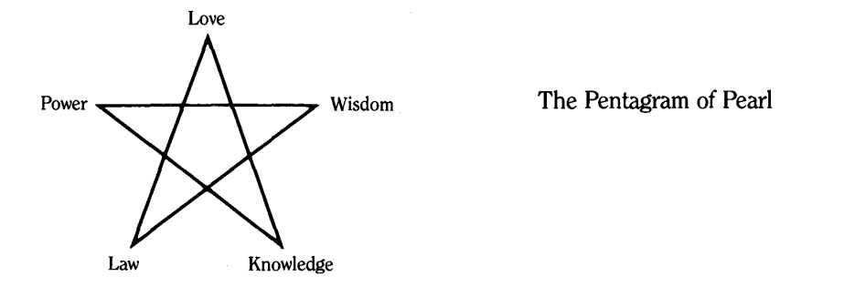
Hold the Pentagram of Pearl, in both hands. Breathe deeply and feel the power of its points of Love, Wisdom, Knowledge, Law, and Power.
a. Love is the moving energy of Life. It is blindly erotic and deeply personal, a passionate, prideful, powerful caring for oneself and others. It is the law of the Goddess and the essence of magic.
b. Wisdom is knowing how to apply knowledge—and how not to apply it
c. Knowledge is learning, the power of the mind to understand and describe the universe Knowledge is knowing what to say; wisdom is knowing whether or not to say it. Knowledge gives answers; wisdom asks questions. Knowledge can be taught; wisdom grows out of experience, out of making mistakes.
d. Law is natural law. When we break natural laws, we suffer the consequences as a natural result of our actions, not as a punishment If you break the law of gravity, you will fall. Magic functions within natural law, not outside of it. Natural law may be more complex than we realize.
e. Power, again, is the power that comes from within, when love, knowledge, wisdom, and law are united. Power, rooted in love and tempered by knowledge, law, and wisdom, brings growth and healing. Absorb the beauty of the Pentagram of Pearl:’

